Lab Experiment Report

Deploying a Multi-Service Application Using Docker Compose

1. Aim
To design, containerize, and deploy a multi-service web application consisting of a Frontend, a Backend, and a Database using Docker Compose, and to study service orchestration, inter-container networking, and volume-based data persistence.

2. Theory
Docker is a platform that allows applications to be packaged with all their dependencies into standardized units called containers. A real-world application rarely consists of a single component - it typically has a presentation layer (frontend), a business logic layer (backend/API), and a data layer (database). Running each of these as a separate container and managing them individually using docker run commands is tedious and error-prone.
Docker Compose solves this problem by allowing all services of an application to be defined declaratively in a single YAML file (docker-compose.yml). With one command, docker compose up, Compose builds images, creates a private network, starts all containers in the correct order, and connects them together.
Key concepts used in this experiment:
- Service: A container definition (built from a Dockerfile or a base image) representing one component of the application.
- Image vs Build: 'image' pulls a ready-made image (e.g. mysql:8) from Docker Hub; 'build' compiles a custom image from a local Dockerfile.
- Networking: Compose automatically creates a bridge network. Containers can reach each other using the service name as the hostname (Docker's internal DNS), instead of IP addresses.
- Port Mapping: 'host_port:container_port' exposes a container's port to the host machine so it can be accessed from a browser.
- Volumes: Persistent storage that exists outside the container's lifecycle, so data (like database files) survives container restarts and recreation.
- depends_on: Controls the startup order of services, though it does not wait for the application inside the container to be fully ready.

3. Software / Tools Required
- Docker Engine (v20 or above)
- Docker Compose plugin (v2)
- A code editor (VS Code / nano)
- Web browser

4. System Architecture
The application follows a standard 3-tier architecture, with each tier running in its own container on a shared Docker bridge network defined in docker-compose.yml:
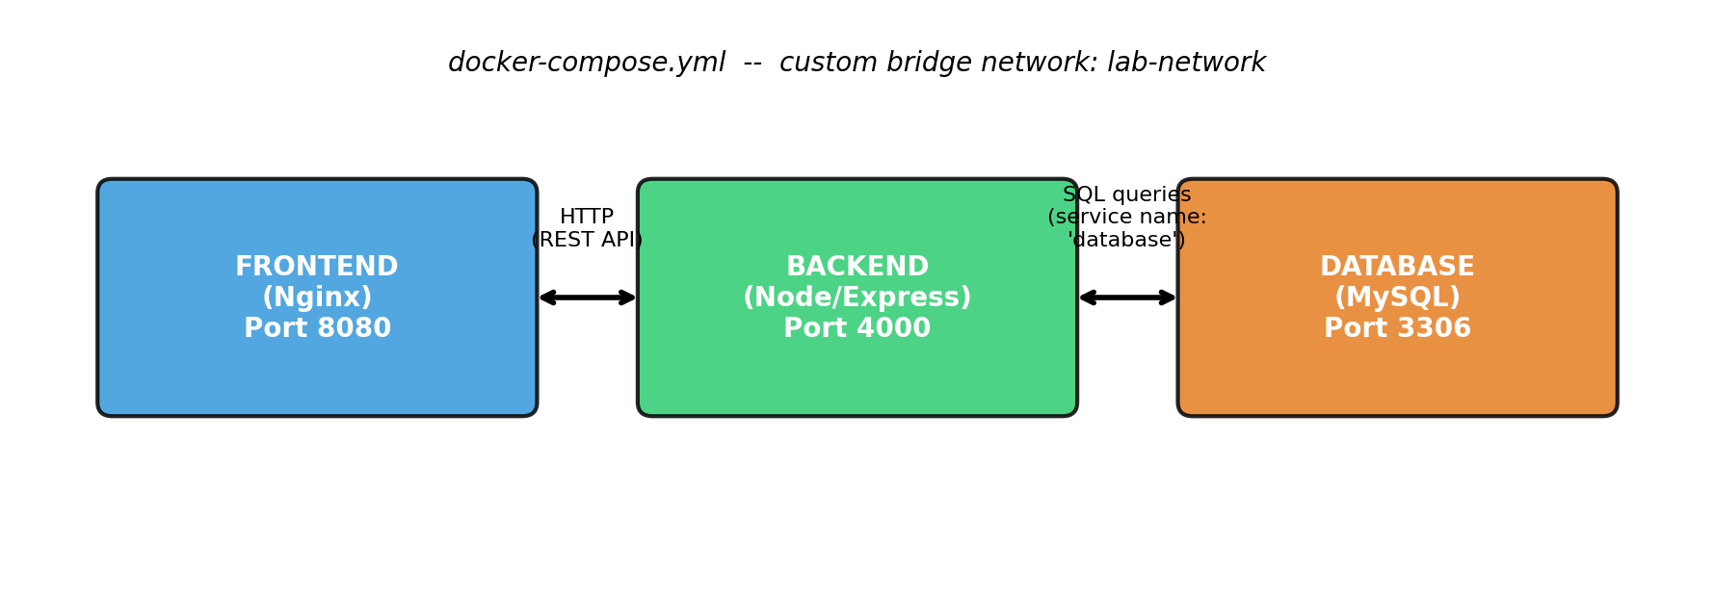
- Frontend: Nginx container serving a static HTML page (port 8080 on host).
- Backend: Node.js/Express REST API container that handles requests from the frontend and executes queries on the database (port 4000 on host).
- Database: MySQL 8 container that stores application data persistently using a named Docker volume (port 3306 on host).

5. Project Directory Structure
multi-service-app/
├── docker-compose.yml
├── frontend/
│ ├── Dockerfile
│ └── index.html
├── backend/
│ ├── Dockerfile
│ ├── server.js
│ └── package.json
└── README.md

6. docker-compose.yml
This file defines all three services, their build context, exposed ports, environment variables, network, and the persistent volume for the database.
version: "3.9"

services:

frontend:
build: ./frontend
container_name: lab_frontend
ports:
- "8080:80"
depends_on:
- backend
networks:
- lab-network

backend:
build: ./backend
container_name: lab_backend
ports:
- "4000:4000"
environment:
DB_HOST: database
DB_USER: root
DB_PASSWORD: root123
DB_NAME: labdb
depends_on:
- database
networks:
- lab-network

database:
image: mysql:8
container_name: lab_database
restart: always
environment:
MYSQL_ROOT_PASSWORD: root123
MYSQL_DATABASE: labdb
ports:
- "3306:3306"
volumes:
- db-data:/var/lib/mysql
networks:
- lab-network

networks:
lab-network:
driver: bridge

volumes:
db-data:

7. Backend Code (server.js)
The backend is a Node.js/Express application that connects to the database container using the hostname 'database' (the Compose service name), not 'localhost'. This demonstrates Docker's internal DNS-based service discovery.
const express = require('express');
const mysql = require('mysql2');
const cors = require('cors');

const app = express();
app.use(cors());
app.use(express.json());

// Connect to the "database" service using its Compose service name as hostname
const db = mysql.createPool({
host: process.env.DB_HOST || 'database',
user: process.env.DB_USER || 'root',
password: process.env.DB_PASSWORD || 'root123',
database: process.env.DB_NAME || 'labdb',
waitForConnections: true,
connectionLimit: 10
});

// Create table if it doesn't exist, then seed one row
function initDb() {
db.query(
`CREATE TABLE IF NOT EXISTS visits (
id INT AUTO_INCREMENT PRIMARY KEY,
visited_at DATETIME DEFAULT CURRENT_TIMESTAMP
)`,
(err) => {
if (err) {
console.log('Waiting for database to be ready...', err.message);
setTimeout(initDb, 3000); // retry until MySQL is up
} else {
console.log('Database initialized successfully');
}
}
);
}
initDb();

// Health check route
app.get('/api/health', (req, res) => {
res.json({ status: 'backend is running' });
});

// Route that talks to the database
app.get('/api/visits', (req, res) => {
db.query('INSERT INTO visits () VALUES ()', (err) => {
if (err) return res.status(500).json({ error: err.message });
db.query('SELECT COUNT(*) AS total FROM visits', (err, rows) => {
if (err) return res.status(500).json({ error: err.message });
res.json({ totalVisits: rows[0].total });
});
});
});

const PORT = process.env.PORT || 4000;
app.listen(PORT, () => console.log(`Backend running on port ${PORT}`));

8. Frontend Code (index.html)
The frontend is a static HTML page served by Nginx. It calls the backend's REST API from the browser to fetch data recorded in the database.
<!DOCTYPE html>
<html lang="en">
<head>
<meta charset="UTF-8" />
<title>Docker Compose Lab - Frontend</title>
<style>
body { font-family: Arial, sans-serif; text-align: center; margin-top: 80px; background: #f4f6f8; }
h1 { color: #2c3e50; }
button { padding: 10px 20px; font-size: 16px; cursor: pointer; border: none;
background: #2980b9; color: white; border-radius: 6px; }
button:hover { background: #1f6690; }
#result { margin-top: 20px; font-size: 18px; color: #2c3e50; }
</style>
</head>
<body>
<h1>Multi-Service Docker Compose Lab</h1>
<p>Frontend (Nginx) &rarr; Backend (Node/Express) &rarr; Database (MySQL)</p>
<button onclick="checkVisits()">Ping Backend + Database</button>
<div id="result"></div>

<script>
async function checkVisits() {
document.getElementById('result').innerText = "Loading...";
try {
// Note: backend URL is the host machine's mapped port, not the service name,
// because this code runs in the user's BROWSER, not inside a container.
const res = await fetch('http://localhost:4000/api/visits');
const data = await res.json();
document.getElementById('result').innerText =
"Total visits recorded in database: " + data.totalVisits;
} catch (err) {
document.getElementById('result').innerText = "Error reaching backend: " + err;
}
}
</script>
</body>
</html>

9. Steps Performed

Step 1: Verify Docker installation
docker --version
docker compose version

Step 2: Create the project folder structure
mkdir multi-service-app && cd multi-service-app
mkdir frontend backend

Step 3: Write Dockerfiles and application code
Created frontend/Dockerfile (Nginx base image), backend/Dockerfile (Node base image), and the application source files shown in Sections 7 and 8.

Step 4: Write docker-compose.yml
Defined the three services - frontend, backend, and database - along with a custom bridge network (lab-network) and a named volume (db-data) as shown in Section 6.

Step 5: Build and start all services
docker compose up --build
This command reads docker-compose.yml, builds the frontend and backend images from their Dockerfiles, pulls the mysql:8 image, creates the lab-network bridge network, creates the db-data volume, and starts all three containers.

Step 6: Verify all containers are running
docker compose ps
[Insert screenshot of terminal output here showing frontend, backend, and database containers in 'running' state]

Step 7: Test the application
- Opened http://localhost:8080 in a browser to view the frontend page.
- Clicked the 'Ping Backend + Database' button, which sent a request to http://localhost:4000/api/visits.
- The backend inserted a row into MySQL and returned the total visit count, confirming all three tiers were communicating correctly.
[Insert screenshot of the frontend page and the visit counter here]

Step 8: Inspect logs and network
docker compose logs -f backend
docker network ls
docker network inspect multi-service-app_lab-network

Step 9: Stop and clean up
docker compose down # stop and remove containers + network
docker compose down -v # also remove the database volume

10. Observations
- All three containers (frontend, backend, database) started successfully with a single 'docker compose up' command.
- The backend was able to reach the database container using the service name 'database' as the hostname, confirming Docker Compose's built-in DNS-based service discovery.
- Data written to MySQL persisted across container restarts because it was stored in a named volume (db-data) rather than inside the container's writable layer.
- Running 'docker compose down -v' removed the volume and reset the visit counter to zero on the next run, confirming the role of volumes in data persistence.
- Port mapping allowed the host machine's browser to access services running inside isolated containers.

11. Conclusion
A multi-service application with a Frontend, Backend, and Database was successfully containerized and deployed using Docker Compose. The experiment demonstrated how Compose simplifies multi-container orchestration through a single declarative YAML file, how containers communicate over a custom bridge network using service names, and how named volumes provide persistent storage independent of container lifecycles. This confirms Docker Compose as an effective tool for developing, testing, and deploying multi-tier applications in a consistent and reproducible manner.

